# Introduction

Take what you have learned from the three previous assignments and put it all together. Experiment and iterate and ultimately polish to completion a single, simple and cohesive final game.

# Research

For this assignment, you will need to go beyond what is covered in lab discussion. Take full advantage of the CProcessing documentation, forum and other resources to find new functionality and clever solutions.

<https://github.com/DigiPen-Faculty/CProcessing/wiki>

# Objectives

Your goal is to “Make Game”. We want to leverage the previous assignments and either continue from there or start fresh to build a complete game. The final product should be something you are proud of and can use to show others what you are doing at DigiPen. Team projects will start the following week so be sure to keep your scope small and finish well. Please pour some genuine time and energy into making this great!

**Assignment requirements:**

* Use gamestate management to move between states.
* Display the DigiPen Logo, using the same guidelines as stated in Assignment 1:
  + Use supplied and approved DigiPen logos ONLY (included in the empty project).
  + Display the official DigiPen logo all by itself as the first screen upon launching.
  + The logo must be displayed unaltered for at least 2 seconds, after which you can move on or start modifying the logo in an artistic way.
* Credits
  + Include your name, instructor, special thanks and DigiPen copyright. This can be a menu option or on the win/lose screen.

**You DO NOT need all of these, but consider for polish. Incorporate any that make sense:**

* Audio (sound effects and background music if possible)
* Custom mouse cursor (easy to do and shows you care)
* High scores or leaderboard (possible to save this to a text file, fopen)
* Animations
* Cool effects like particles or screen shake
* Nice transitions between scenes like fades or swipes
* … and anything else you can come up with

This is just one small list, but each game will be unique. Please seek out the instructors or TAs to preview your work and get additional ideas and feedback before submitting.

# Submission

There are two parts to your assignment submission. You need to show off your work in class to the instructor or a TA as well as submit the code via Moodle.

In class sign-off will occur at the beginning of the following lab class. Please get to class on time and open your project so you are ready as the Instructor and TAs walk around and see your work. We will want to see that you met the objectives and that you engaged with the assignment in a creative and curious way.

The code will be submitted via Moodle prior to sign-off in class. Make sure to update the file comment headers with your personal info. (name, email etc.) Zip the entire project (minus the Debug/Release folders). Refer to the following image, this is what your Zip file should contain.

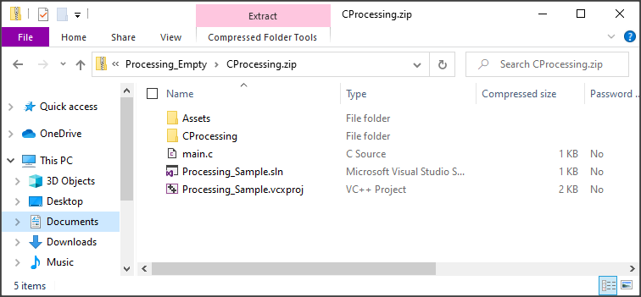

Plus all additional game state files.  
(ie. gamestate_splash, gamestate_logo, etc.)

Follow this assignment naming convention:

* GAM100F21<Section Letter>_<Login ID>_ FinalGame.zip
* Example: GAM100F21A_andrea.ellinger_FinalGame.zip